CHAPTER 8 - PLANTS RESPONSE TO THE ENVIRONMENT
PLANT HORMONES
QUESTION 1
1. Gibberellins
2. Gibberellins
3. Abscisic acid
4. Gibberellins
5. Tropism
6. Negative response
7. Apical dominance

QUESTION 2
1. Growth movement of a part of a plant in response to an external stimulus.
2. Light
3. Auxin
4. Unilateral exposure to light will result in auxin moving to darker/shaded side of the stem tip. A high concentration of auxin on the darker/shaded side accelerates growth. This causes cell division and cell elongation on the darker/shaded side which causes the stem to bend towards the light source.
5. Favourable position for the leaves to receive maximum sunlight for photosynthesis. Exposes the flowers more favourably, allowing for easy pollination of flowers/ allowing for easier seed dispersal.
6. The high auxin concentration would result in the rapid cell growth in the weeds which will exhaust the plant-killing the plant.

QUESTION 3
1. The radical grows towards gravity and the plumule (young shoots) grows away from gravity
2. Geotropism/positively geotropic
3. To eliminate the effect of light on the growth movement of the young shoot (plumule)
4. Same species of plant used/identical clinostats used in each set up/seeds exposed to the same environmental conditions/same period of time used for each set up/same person to conduct the investigation
5. The sample size was too small/ the investigation was not repeated several times
6. To verify the results of the investigation
7. Under the influence of gravity the auxins accumulate on the lower side of the radicle. The growth on the lower side is inhibited due to the increased concentration of auxin. The upper side of the radicle has a lower auxin concentration these cells therefore elongate more causing the radicle to bend and grow downwards
8. Gravity resulted in the movement of auxin towards the lower part of the shoot when the shoot was in a horizontal position. Since high concentration of auxin in the lower part of the shoot promotes cell division and elongation it resulted in the growth movement of the shoot away from gravity.

QUESTION 4
1. The cell elongation in the coleoptiles will increase/decrease/remain the same as the auxin concentration increases/decreases.
2. a) Auxin concentration
b) Average length of coleoptiles
3. Group A. It verifies the results of the investigation.
4. Removed the effect of auxin produced at the tip as there can be different concentrations produced by each coleoptile.
5. Same species of bean plant was used. The coleoptiles used were of the same length.
6. Increase the sample size. Repeat the investigation several times and calculate the average.
7. Line graph illustrating the relationship between the auxin concentration and the average length of the coleoptiles.
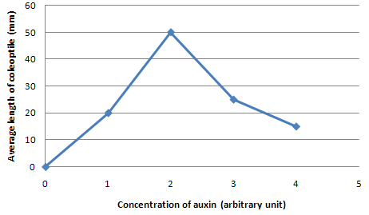
8. 2 arbitrary units. At this concentration the average length of the coleoptiles was the longest.
9. An increase in the auxin concentration results in an increase cell elongation of the coleoptiles until the optimum concentration. An increase in the auxin concentration past the optimum results inhibits/decreases cell elongation.

PLANT DEFENCE MECHANISMS
QUESTION 1
1. Thorns
2. Eating of the plant is uncomfortable to the herbivore as it may cause pain to the herbivore during consumption which in turn will prevent the herbivore from eating the plant or slow down the rate in which they consume the plant.
3. Chemical secretions. Some chemical secretions are bitter and difficult to digest.

